Thongsbridge Mini Teams
Dominate at Yorkshire Team Tennis!
Mini Red
We had 3 teams of 4 entered and they travelled to Hull on Saturday 16th June
A Team B Team C Team
Daniel Louis Ella
Billy Patrick Ethan
Evan Oscar Tom
Henry Elena William

The C Team were in the 2nd division and finished 3rd in their group winning one match. In the play off match they beat Ilkley B 10-6 to finish in 3rd place.
The B Team had some tough opponents and whilst they were able to win rubbers they could not win any matches in their round robin boxes. However in their play off matches they beat Heaton and so finished in 5th equal position
The A Team won their group matches well taking out Heaton and Hallamshire and were up against Ilkley in the final. The score was 4 rubbers all at the end but thankfully Thongsbridge had won more overall points so were crowned the Yorkshire Mini Red Team Tennis Champions for 2018!
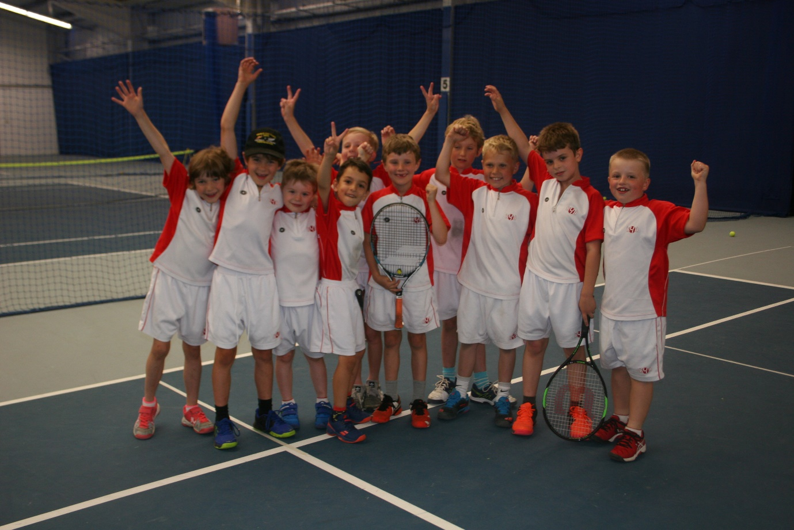

Mini Orange
We have 4 teams competing at Mini Orange this year in Team Tennis
A Team B Team C Team D Team
Louis Ben Sebby Toby
Dan Holly Finlay Joseph
Dan Gylo Jake Harvey
Elliot Scarlett Charlotte James

D Team
The D Team travelled to Hull on Sunday 10th June
They had a great day out and finished 2nd in their group. They then played their play off match and lost a close game to Nuffield’s B team meaning they finished 4th in Division 3
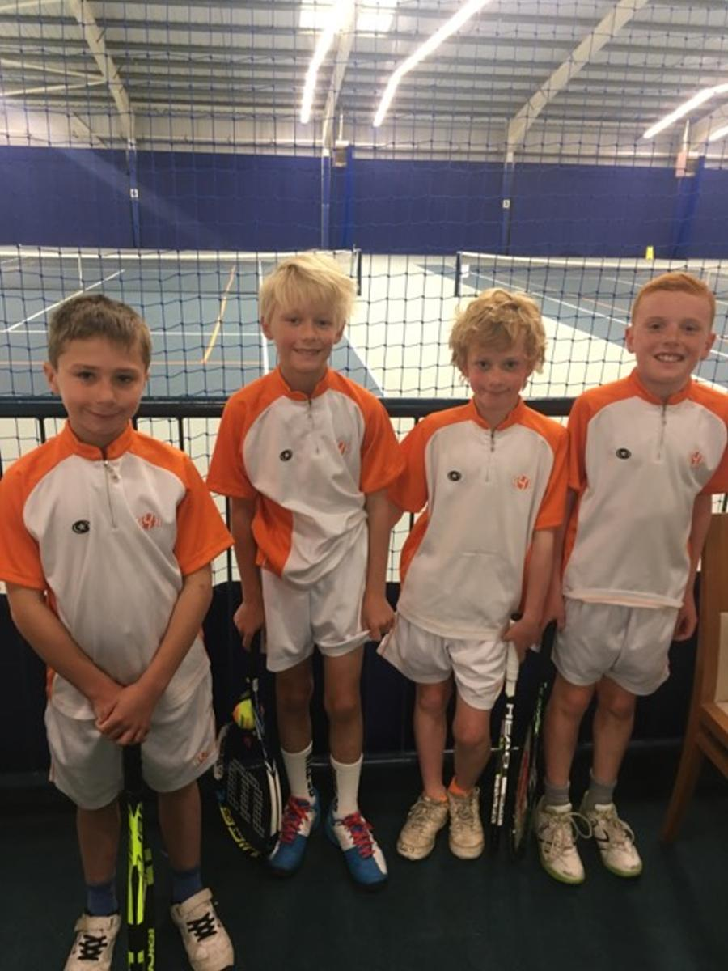

The A, B and C Teams travelled to Hull on Saturday 19th June
C Team
The C Team finished in last place in their box and had some tough games against our B team and Ilkley! They then played Graves and put up a good fight but lost to Graves so finished 6th overall in Division 1
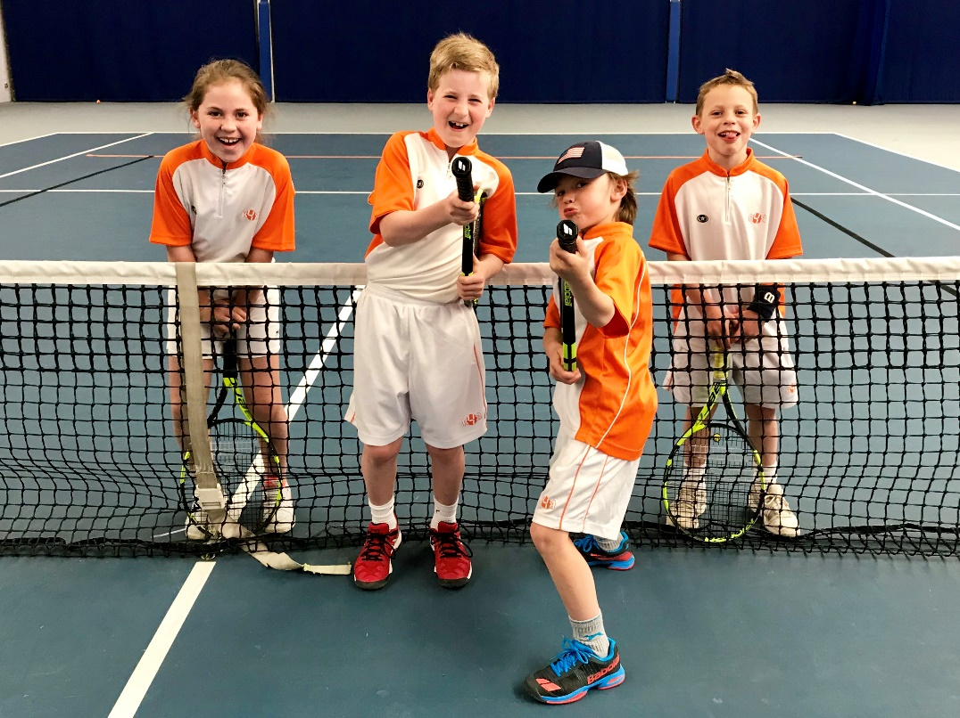

B Team
The B team finished in 2nd position in their box, beating the C Team but losing to Ilkley. In their play off match they drew with Hull 6-6 but unfortunately lost out on points so finished 4th place overall in Division 1
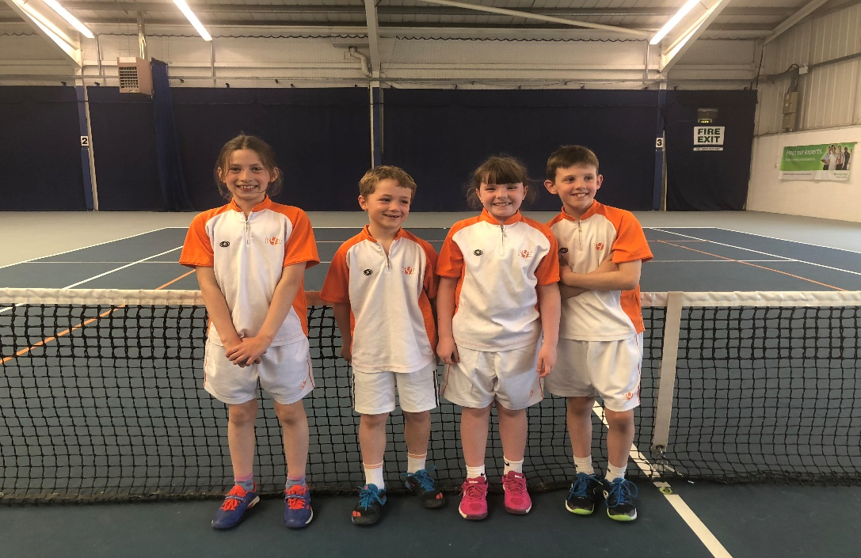

A Team
The A Team were convincing winners in their round robin box winning both matches 12-0. In the final they were up against Ilkley A and put up a great performance to win 8-4 so winning Division 1 and being crowned Yorkshire Mini Orange Team Tennis Champions for 2018!

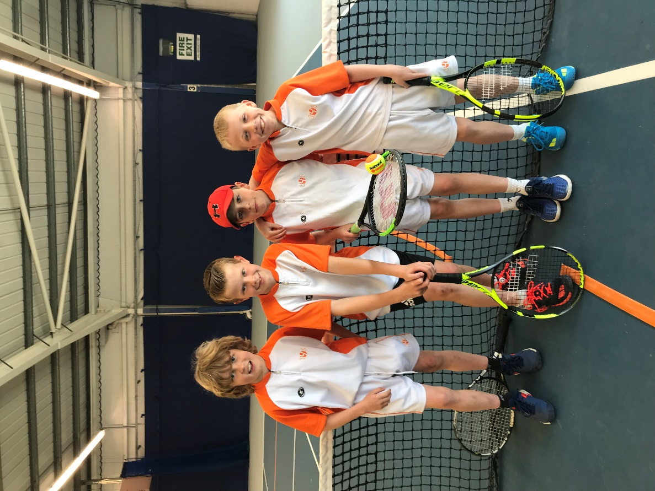

Green Team
The 3 Green Teams travelled to Leeds on Saturday 16th June
A Team B Team C Team
Louis Taylor Dan
Tom Harrison Elliot
Henry Louis Lucy
Aodhan Dan Hudson

C Team
The C Team were competing in Division 2 with another 3 teams. They managed to finish 2nd in their group winning 2 matches and putting in some impressive performances!

B Team
The B Team were in Division 1 with another 4 teams including the A Team! They managed to get 2 draws and 1 win and only lost to our A Team, so finished in 3rd place. Some tough tennis but they played well throughout the day

A Team
The A Team were in Division 1 and were the favourites! Luckily, they coped with the pressure and comfortably won their matches to be crowned Yorkshire Mini Green Team Tennis Champions for 2018!
